**PROJECT TITLE: SMART WATER FOUNTAIN**

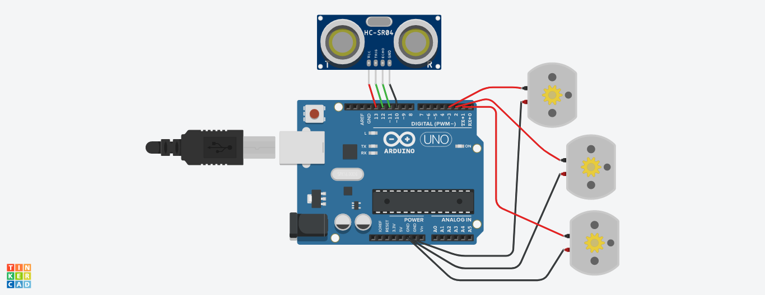

**CODE :**

**trigPin = 12**

**echoPin = 10**

**vcc = 13**

**gnd = 10**

**duration = 0**

**distance = 0**

**def setup():**

**global duration, distance**

**pinMode(1, OUTPUT)**

**pinMode(2, OUTPUT)**

**pinMode(3, OUTPUT)**

**pinMode(trigPin, OUTPUT)**

**pinMode(echoPin, INPUT)**

**pinMode(vcc, OUTPUT)**

**pinMode(gnd, OUTPUT)**

**digitalWrite(vcc, HIGH)**

**digitalWrite(gnd, LOW)**

**Serial.begin(9600)**

**def loop():**

**global duration, distance**

**digitalWrite(trigPin, HIGH)**

**delayMicroseconds(10)**

**digitalWrite(trigPin, LOW)**

**distance = duration * 0.034 / 2**

**Serial.print("Distance:")**

**Serial.println(distance)**

**delay(1000)**

**if distance < 50:**

**digitalWrite(1, HIGH)**

**delay(1000)**

**digitalWrite(2, HIGH)**

**delay(1000)**

**digitalWrite(3, HIGH)**

**delay(1000)**

**else:**

**digitalWrite(1, LOW)**

**delay(1000)**

**digitalWrite(2, LOW)**

**delay(1000)**

**digitalWrite(3, LOW)**

**delay(1000)**

**setup()**

**while True:**

**loop()**

**CODE EXPLANATION:**

* The code starts with the pinMode command for each of the pins.
* The first two are OUTPUT, and the last two are INPUT.
* The next line is a delayMicroseconds function that sets up a 10 millisecond delay in between pulses on the trigPin.
* This will be used to calculate distance later on in this code.
* Next, there is a digitalWrite function that turns HIGH or LOW depending on whether it's being called from inside or outside of an if statement (the else clause).
* Inside of an if statement, it's set to LOW; outside of one, it's set to HIGH.
* After that comes another digitalWrite function which turns ON or OFF all three LEDs based on how far away they are from you (distance=duration*0.034/2).
* The code is a simple example of how to use the Arduino's digital pins.
* The code will turn on an LED for 10 milliseconds, then turn it off.
* It will also measure the time in microseconds and print out a value of distance.
* **AI & ADS:**

**Smart water management is a critical area where AI (Artificial Intelligence) and ADS (Advanced Data Systems) technology can significantly contribute to addressing water problems. Smart water management involves the use of advanced technologies to monitor, analyze, and optimize water usage, distribution, and treatment processes. Here's how AI and ADS can be leveraged for effective water management:**

1. **Real-time Monitoring and Sensors:** Implement IOT (Internet of Things) sensors and devices in water infrastructure to collect real-time data on water quality, consumption, leak detection, and infrastructure health. These sensors can be used to monitor water levels, pressure, temperature, and other relevant parameters.
2. **Data Aggregation and Processing:** Utilize ADS technology to aggregate and process the vast amounts of data generated by sensors and other sources. This includes integrating data from different systems and sources, cleaning and filtering the data, and preparing it for analysis.
3. **Predictive Analytics and Machine Learning:** Employ AI and machine learning algorithms to analyze historical and real-time data to predict water consumption patterns, identify potential leaks, optimize pump operation, and anticipate maintenance needs. Predictive analytics can help in forecasting demand and planning for future requirements.
4. **Demand Forecasting and Optimization:** AI can analyze historical consumption patterns, weather forecasts, population growth, and other relevant factors to accurately forecast future water demand. This enables utilities to optimize water supply and distribution, ensuring that water is available when and where it is needed.
5. **Leak Detection and Reduction:** AI algorithms can detect anomalies in water flow and consumption patterns that may indicate leaks or wastage. Early detection of leaks helps in prompt repairs and reduction of water losses, ultimately saving water and improving system efficiency.

* **DAC:**

**Digital Water Quality Assessment and Control (DAC) technology plays a significant role in addressing water-related problems and improving smart water management. DAC technology leverages digital tools and data analytics to monitor, assess, and control water quality and distribution. Here are some ways in which DAC technology can be applied to address water problems and enhance smart water management:**

1. **Real-time Monitoring:** DAC technology allows for continuous real-time monitoring of various water quality parameters, such as pH, turbidity, dissolved oxygen, and chemical contaminants. Sensors and data collection devices are deployed throughout the water supply and distribution network to provide instant data.
2. **Early Warning Systems:** DAC systems can detect anomalies and deviations from standard water quality parameters, providing early warning signals of potential contamination or system issues. This enables authorities to respond swiftly and prevent water quality crises.
3. **Data Analytics:** By collecting and analyzing extensive data on water quality, DAC technology can identify patterns and trends, helping water management authorities make informed decisions about resource allocation, infrastructure upgrades, and water treatment processes.
4. **Remote Control:** DAC technology allows for remote control of water treatment processes, allowing adjustments and optimization based on real-time data. This improves energy efficiency and the overall performance of treatment facilities.
5. **Leak Detection:** Smart water management systems can integrate DAC technology to identify and locate water leaks in distribution networks promptly. This reduces water loss and helps conserve resources.

* **IOT:**

**IOT (Internet of Things) technology plays a crucial role in addressing water-related challenges and enhancing smart water management. By integrating IOT devices and sensors into water management systems, it's possible to collect real-time data, monitor, and control various aspects of water resources and infrastructure. Here are some ways IOT technology can be applied to solve water problems:**

1. **Remote Monitoring**: IOT sensors placed throughout water distribution networks, reservoirs, and treatment plants can provide real-time data on water quality, water levels, and equipment status. This helps in early detection of issues and enables proactive maintenance.
2. **Leak Detection**: IOT sensors can identify leaks in water pipelines by monitoring pressure changes and flow irregularities. This early detection can prevent water loss and infrastructure damage.
3. **Water Quality Monitoring**: IOT-enabled sensors can continuously measure parameters like pH, turbidity, dissolved oxygen, and contaminant levels. Any deviations from accepted standards can trigger alarms, ensuring water quality compliance.
4. **Flood Management**: IOT sensors positioned in flood-prone areas can monitor water levels and weather conditions. When thresholds are reached, alerts can be sent to authorities and residents, enabling timely flood management.
5. **Smart Irrigation**: IOT-based smart irrigation systems use sensors to measure soil moisture and weather conditions. This data is used to optimize irrigation schedules, conserving water resources in agriculture.

* **CAD:**

**Computer-Aided Design (CAD) technology can play a significant role in addressing water-related issues through smart water management. Smart water management involves using data, sensors, and automation to optimize the use and distribution of water resources efficiently. CAD technology can be applied in various aspects of smart water management to design, plan, and monitor water systems. Here are some ways CAD technology can be used in this context:**

1. **Infrastructure Design and Planning:** CAD software allows engineers and planners to design and model water infrastructure, including pipelines, treatment plants, and reservoirs. They can create 2D and 3D models that consider factors such as terrain, capacity, and flow rates to optimize the layout and design of water systems.
2. **Geospatial Analysis:** Geographic Information Systems (GIS) integrated with CAD can provide spatial data and analysis tools to help manage water resources effectively. CAD-GIS integration can help in the identification of water sources, catchment areas, and the best locations for water infrastructure.
3. **Hydraulic Modeling:** CAD software can be used to create hydraulic models of water distribution networks. These models simulate how water flows through the system under various conditions, enabling planners to optimize network design, detect potential problems, and plan for system improvements.
4. **Asset Management:** CAD technology can help track and manage water infrastructure assets efficiently. By creating digital models and maintaining accurate records of infrastructure components, it's easier to plan for maintenance, repair, and replacement, ensuring the system's long-term reliability.
5. **Remote Monitoring and Sensor Integration:** CAD can be integrated with data from remote sensors and IOT devices that monitor water quality, consumption, and infrastructure conditions. This allows for real-time data collection and analysis, helping water utilities make informed decisions.

Top of Form

Top of Form

**Top of Form**

**Top of Form**